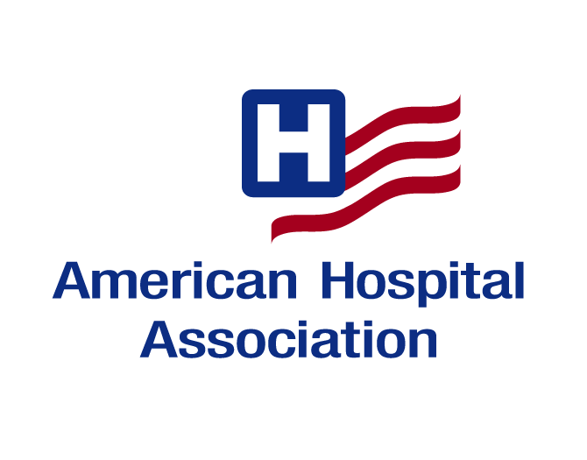

AHA Member Conference Call
Thursday, July 9th, 2009

Using Mid-Level Professionals
In
Psychiatric Treatment Programs

Conference Call Follow-up

1. Request for additional information: _________________________________________________
_________________________________________________________________________________
_________________________________________________________________________________

2. Questions or comments: __________________________________________________________
_________________________________________________________________________________
_________________________________________________________________________________

3. Evaluation: Strongly Strongly

Agree Disagree
- The material provided on the call was informative. 5 4 3 2 1
- My questions were addressed on the call. 5 4 3 2 1
- There was ample time on the call to ask questions 5 4 3 2 1
or make comments.
--------------------------------------------------------------------------------------------------------------------

Name: _____________________________________________________________
Title: _____________________________________________________________
Organization: ________________________________________________________
Address: ____________________________________________________________
City/State/Zip: _______________________________________________________
Phone: ____________________________Fax: _____________________________
E-mail: _____________________________________________________________

Please return this form after the call to Rebecca Chickey, AHA Member Relations

rchickey@aha.org, or 312-422-3472 (FAX)

