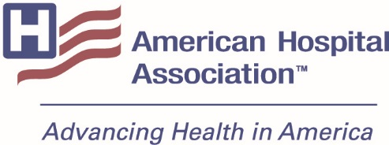

**APPLICATION FOR AHA NOVA AWARD®**

*Collaboration for healthier communities*

The AHA NOVA Award recognizes outstanding collaboration by hospitals and health systems for healthier communities. Specifically, the award honors AHA members that:

* improve community health status whether through health care, economic or social initiatives, and
* are collaborative—joint efforts among health care systems or hospitals, or among hospitals and other community leaders and organizations.

Awards will be presented at the AHA Leadership Summit, July 26-28, 2018, in San Diego.

**INSTRUCTIONS**

Complete this cover page and the following summary sheet. Also, submit a detailed program description on the nominated program.

**Name and address of all participating hospital/system(s):**

**Contact person:**

Title: Address:

Telephone: E-mail:

CEO:

Telephone: E-mail:

**Name of program nominated:**

As CEO and Board chair of the hospital(s)/health care system(s), we are nominating this project for an AHA NOVA Award.

CEO Signature(s): _______________________________________________________________

Typed name(s): __________________________________________________________________

Chair Signature(s): _______________________________________________________________

Typed name(s): __________________________________________________________________

*Nominations for the 2018 AHA NOVA Award should be e-mailed to* [*nova@aha.org*](mailto:nova@aha.org) *by Dec. 8, 2017.*

**AHA NOVA AWARD®**

# **2018 Application**

1. Briefly describe the program’s goals and methods.
2. In addition to the hospitals/health systems submitting the application, who are the collaborative partners in this program?
3. What are the unique elements of this program that set it apart or contribute most to its success?
4. What elements are easily replicable by other communities?
5. Please attach a double-spaced manuscript of no more than 10 pages. Manuscripts must follow these headings:

* **Impetus for program** – why the program was conceived, what leadership promoted the idea, etc.)
* **Program description –** what are the program’s goals; what population does it reach; how does it operate; how is it funded; what are the roles of the collaborative partners)
* **Outcome**
  + Current efforts and methods being used to evaluate and measure the impact of the program
  + Documentation of program effectiveness (e.g., changes in health behavior, health status, access to care, etc.)
* **Advice to others** – how can others replicate your program or achieve similar goals

Information on past AHA NOVA Award recipients can be found on AHA’s website [www.aha.org/nova](http://www.aha.org/nova). Please call 312-422-2712 with any questions.

All hospital/health system partners in collaborative efforts must be involved in submitting the nomination, and at least one partner must be an AHA hospital or health care system member. If the program involves collaborative efforts with community agencies or non-hospital providers, the nomination should be accompanied by letters of support from these partners.

Applications are due Dec. 8, 2017, and should be emailed to [nova@aha.org](mailto:nova@aha.org).

The Association for Community Health Improvement (ACHI) is the AHA NOVA Award’s educational affiliate.