May 1, 2023

National Hospital Week, May 7-13,

New Resources Now Available

Highlight the many ways your hospital, health system and health care workers support and care for the community; Use #WeAreHealthCare on all social posts

This National Hospital Week (NHW), the AHA will use the theme “We Are HealthCare, caring for patients; strengthening communities” to recognize and celebrate the 6.3 million individuals who work in America’s hospitals and health systems and the vital role they play in our society.
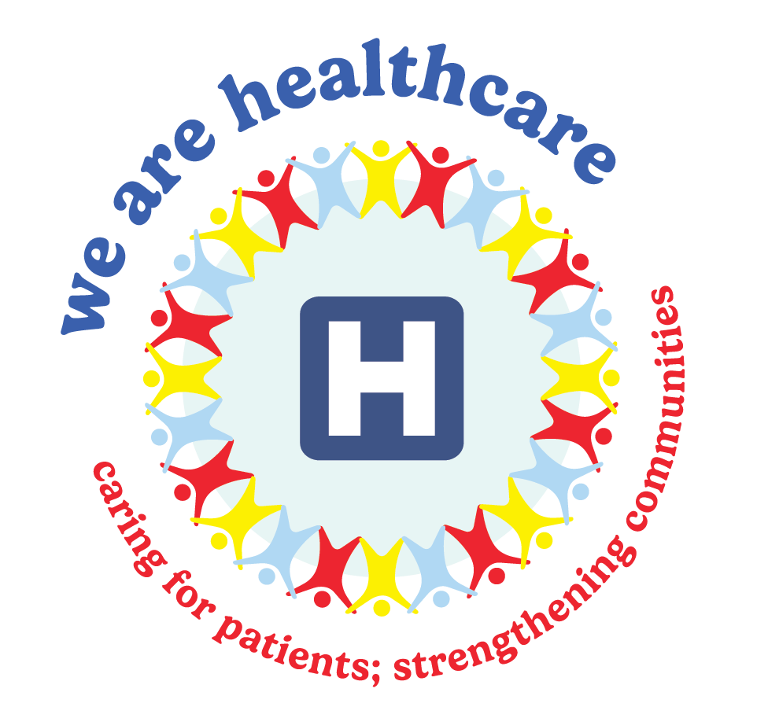

Key highlights
National Hospital Week #WeAreHealthCare resources include:
- Customizable video;
- Social media resources and graphics; and
- NHW logo social profile takeovers.
AHA created a variety of resources to assist hospitals and health systems in celebrating National Hospital Week, May 7-13, and National Nurses Week (NNW), May 6-12. These weeks provide an extra opportunity to recognize the amazing commitment of America’s health care workers. Please join us in this effort to help celebrate their story.

During this special time of recognition, AHA will further emphasize the tremendous impact hospitals and health systems have on advancing health for patients and communities through print and digital advertisements targeting the public and Washington lawmakers and policymakers.

Resources

Videos. The AHA produced a new video spotlighting the important role that hospitals have played throughout history. The video underscores the various milestones and innovations in medical science led by American hospitals and health systems. Access the video on our National Hospital Week webpage.

Social Engagement. The AHA developed social content and is encouraging people to show support for health care workers. These resources include:

- Distinct graphics for social media highlighting the great work happening in hospitals across the country organized by the framework below:
  - Benefiting Communities. Share examples of how your hospital meets the health needs of your community. These include serving as an economic engine, investing in the communitiy and addressing the social determinants of health, among many others.
  - Improving Equitable Access to Care. Share how your organization is improving health equity and ensuring that all individuals regardless of circumstance have access to essential health services.
  - Prevention and Wellness. Highlight the many ways your hospital is helping people get and stay healthy, whether that be providing holistic care, including behavioral health services, efforts to improve maternal health, as well as disease education and prevention efforts.
  - Supporting Public Health. Spotlight how your organization works to protect the health of the people and communities you serve by sharing best practices, identifying and preventing disease.
  - Innovation, Research and Quality Improvement. Share examples of how your organization is using telehealth to improve access to care, detecting diseases earlier and innovating to advance medicine and medical care.

- Join in AHA’s social profile takeover by replacing your profile photo with the NHW logo.

- Download the full social media engagement toolkit and social media assets or use the sample posts below. Please use #WeAreHealthCare on all social media posts.
  - Thank you to everyone who works at or supports hospitals! We respect and appreciate all you do to provide safe, quality care for patients. Celebrate with us by saying your own thanks. #WeAreHealthCare
  - Hospitals care for all those in need; serving a vital role within our country. Learn more about the many ways they benefit communities every day, 24 hours a day. #WeAreHealthCare
  - Our nation’s health care workers work day and night, demonstrating compassion and commitment. Celebrate them during #NationalHospitalWeek by listening to and sharing their stories. #WeAreHealthCare
  - Hospitals and health care providers served on the front lines during the pandemic and are still working to provided needed care. During #NationalHospitalWeek take a moment to celebrate them. Get involved today >>> AHA.org/HospitalWeek. #WeAreHealthCare

What you can do
Share this advisory with your communications/marketing, digital and HR teams.

further questions
If you have further questions, please contact AHA at 800-424-4301 and visit the National Hospital Week webpage.

