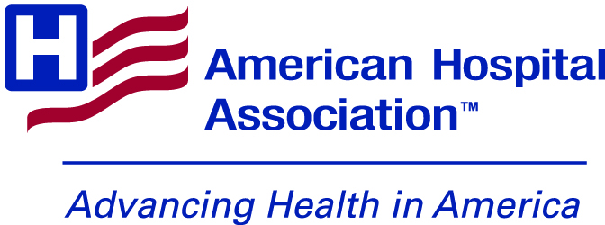

Safety from Violence for Healthcare Employees (SAVE) Act
Social Media Toolkit
Social Posts:
- The AHA applauds the introduction of the Safety from Violence for Healthcare Employees (SAVE) Act. Thank you to @RepLarryBucshon and @RepDean for sponsoring this vital legislation. We look forward to working with Congress to get this passed. #HAVHope
- The AHA supports the passage of the recently introduced Safety from Violence for Healthcare Employees (SAVE) Act. Support this legislation and learn more about creating safer health care workplace, including a guide created in conjunction with @IAHSS #HAVHope <link>
- The AHA looks forward to working with Congress to pass the SAVE Act. The AHA has several resources to help hospitals and health systems enhance protections for their employees #HAVHope <link>
- Hospitals and health systems across the country have invested resources and time into protecting their workforce. The Safety from Violence for Healthcare Employees (SAVE) Act will bolster those protections. Learn how some AHA member hospitals are working to ensure a safe workplace #HAVHope: https://www.aha.org/2021-12-03-workforce-and-workplace-violence-prevention-case-studies

- Three takeaways from the AHA supported SAVE Act:
  - The federal law will protect health care workers from assault or intimidation
  - This is a Bipartisan effort to support health care workers
  - The bill provides federal funding to help hospitals invest in efforts to reduce workplace violence, including through training programs and other resources

- Thanks to the SAVE Act, health care workers can feel safer going to work without fear of violent attacks while they provide necessary care for their patients. RT and show your support

- The Safety from Violence for Healthcare Employees (SAVE) Act will protect America’s health care workers in the workplace by providing protections like those in the federal statute that criminalizes the assault and intimidation of aircraft and airport workers. We believe the hardworking staff at our hospitals and health systems deserve those same legal protections.

- According to the Bureau of Labor Statistics, health care workers are 5x more likely to be physically attacked on the job. Help end this issue by supporting the SAVE Act now: <link>

- Did you know that health care workers are victims of violence in the workplace? Studies indicate that in the last two years, 44% of nurses reported being subject to physical violence and 68% reported verbal abuse. Learn more about the SAVE Act which hopes to end this trend: <link>

- Workplace violence harms health care workers, and many suffer from both physical and psychological trauma after an incident. Let’s end this together by supporting the SAVE Act: <link>

Twitter Link: https://www.aha.org/workplace-violence?utm_source=twitter&utm_medium=organic&utm_campaign=workplace-violence-bill

Facebook: https://www.aha.org/workplace-violence?utm_source=facebook&utm_medium=organic&utm_campaign=workplace-violence-bill

LinkedIn: https://www.aha.org/workplace-violence?utm_source=facebook&utm_medium=organic&utm_campaign=workplace-violence-bill

Hashtag:

#HAVHope

Graphics: https://drive.google.com/drive/folders/19MTN14idnUWHUq7_iqs0j11v0t_Af7Xe?usp=sharing

Images:
Building a Safe Workplace and Community PDF, turning into an infographic: https://www.aha.org/system/files/media/file/2021/10/building-a-safe-workplace-and-community-framework-for-hospitals-and-health-systems.pdf

