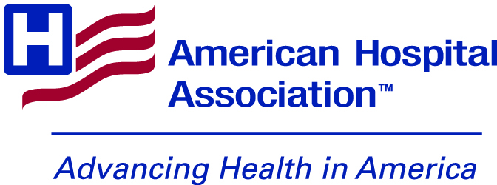

Suicide Prevention Month Toolkit

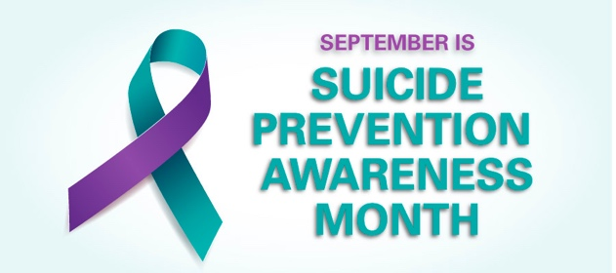
LINKS:

Hashtags: #SuicidePreventionMonth

General Link: https://www.aha.org/suicideprevention

TWITTER:
https://www.aha.org/suicideprevention?utm_source=twitter&utm_medium=organic&utm_campaign=suicide-prevention-month-2022

FACEBOOK:

https://www.aha.org/suicideprevention?utm_source=facebook&utm_medium=organic&utm_campaign=suicide-prevention-month-2022

LINKEDIN:

https://www.aha.org/suicideprevention?utm_source=linkedin&utm_medium=organic&utm_campaign=suicide-prevention-month-2022

Images (Including People Matter Words Matter): https://drive.google.com/drive/folders/1nW15oZOcDx6gaqR78e05m1dMmEtR1yAO?usp=sharing

Suicide Prevention Month Posts:

- The 988 Lifeline helps thousands of struggling people overcome suicidal crisis or mental-health related distress every day. The AHA has resources for those who want to learn more about the 988 crisis line #SuicidePreventionMonth
- Why Boards Should Focus on Suicide Prevention https://trustees.aha.org/why-boards-should-focus-suicide-prevention #SuicidePreventionMonth
- Listen to this Advancing Health podcast to hear a panel discussion about the issues facing rural health care providers – including how they are addressing behavioral health issues: https://soundcloud.com/advancinghealth/aha-celebrates-national-rural-health-day #SuicidePreventionMonth
- As we observe #SuicidePreventionMonth, check out this podcast series, co-developed by the AHA’s Physician Alliance and the Education Development Center, featuring stories of recovery and ideas for supporting colleagues struggling with thoughts of suicide: https://www.aha.org/advancing-health-podcast/be-well-preventing-physician-suicide
- How Respectful Dialogue Can Reduce Mental Health Stigma: https://www.aha.org/news/blog/2022-07-13-how-respectful-dialogue-can-reduce-mental-health-stigma #SuicidePreventionMonth
￼￼
- DYK: Regional behavioral health care networks and community partnerships can reduce wait times for outpatient services by 50%? They are also associated with improved care outcomes. Download the AHA's executive summary on these networks. #SuicidePreventionMonth https://www.aha.org/regional-networks-behavioral-health-improving-access-care
- As we observe #SuicidePreventionMonth, be sure to check out the @AHAPhysAlliance Clinician Well-Being Playbook, which can help hospital leaders provide support for physicians who might be struggling with burnout: https://www.aha.org/physicians/well-playbook

Posts Specific to Health Care Worker Suicide Prevention:

Link: https://www.aha.org/suicideprevention/health-care-workforce/suicide-prevention-guide

Video: Enhancing Well-Being and Preventing Suicide in the Health Care Workforce

Link: https://www.youtube.com/watch?v=bgFnTYaFrLw

- The AHA, in partnership with the CDC, has released a guide that outlines three key drivers of suicidality and offers interventions to help you take action now. Download the guide. #SuicidePreventionMonth

- Whether you are in HR at small rural hospital, a nurse manager in a city trauma center, or a trustee at a health system, supporting the mental well-being of your hospital colleagues is critical. The AHA, in partnership with the CDC, has released a guide that outlines three key drivers of suicidality and offers interventions to help your organization take action. Download the guide. #SuicidePreventionMonth

- You want to help support your colleagues’ mental health needs, but don’t know where to start. The AHA, in partnership with the CDC, has released a guide with curated resources to aid you in your efforts to support your co-workers. Download the guide. #SuicidePreventionMonth

- The AHA, in partnership with the CDC, has released a guide that outlines three key drivers of suicidality among health care workers and offers interventions to help you and your organization take action. Hospitals and health care systems can tailor the interventions to their specific needs. Download the guide. #SuicidePreventionMonth

- AHA’s guide on preventing suicide in the health care workforce is enhanced through podcasts and videos with real life examples, as well as key metrics to help measure success. These practical resources along with the guide will help health care leaders support the mental health well-being of their colleagues. Download the guide. #SuicidePreventionMonth

Podcast: Finding the Right Words: The Role of Peer Support with Mental Health

LINK: https://www.aha.org/advancing-health-podcast/2023-05-24-finding-right-words-role-peer-support-mental-health

- [PODCAST 🎧 ]: For health care workers, finding the right words to support a colleague struggling with their mental health or thoughts of suicide can be challenging. According to Luci New, assistant professor of Nurse Anesthesia at Wake Forest University School of Medicine, the best thing you can say to a struggling colleague is simple: “I care about you.” #SuicidePreventionMonth

Podcast: Preventing Suicides in the Health Care Workforce: The Role of Resilience

LINK: https://www.aha.org/advancing-health-podcast/2023-05-24-finding-right-words-role-peer-support-mental-health

- Check out this Advancing Health podcast with @healthydriven CEO Gina Sharp and Lindsey Harrington, Psy.D., Manager, Psychology and Counseling, about the importance of mental health for health care workers, and how the health system works to support its staff’s mental health needs, including destigmatizing the act of asking for help.
- In this Advancing Health podcast with @healthydriven CEO Gina Sharp and Lindsey Harrington, Psy.D., Manager, Psychology and Counseling, Dr. Harrington discusses the importance of ensuring that hospital leadership earns the trust of their staff when thinking about employee mental health programs.
- For health care workers, putting their own needs first can be counterintuitive to their nature. In this Advancing Health podcast, @healthydriven CEO Gina Sharp and Lindsey Harrington, Psy.D., Manager, Psychology and Counseling, talk about how to break down barriers that can prevent hospital staff from asking for help if they need it.
- In this Advancing Health podcast, @healthydriven’s Lindsey Harrington, Psy.D., manager of psychology and counseling, talks about how the health system changed its culture to help its health care workers feel more comfortable taking time for themselves and their own mental health.
- What are 3 success factors for establishing an employee mental health engagement program at your hospital and health system? Check out this Advancing Health podcast featuring @healthydriven CEO Gina Sharp and Lindsey Harrington, Psy.D., Manager, Psychology and Counseling.

PEOPLE MATTER WORDS MATTER SUICIDE PREVENTION POSTER

LINKS:

TWITTER: https://www.aha.org/people-matter-words-matter?utm_source=twitter&utm_medium=organic&utm_campaign=people-matter-suicide-prevention&utm_content=behavioral-health

FACEBOOK: https://www.aha.org/people-matter-words-matter?utm_source=facebook&utm_medium=organic&utm_campaign=people-matter-suicide-prevention&utm_content=behavioral-health

LINKEDIN: https://www.aha.org/people-matter-words-matter?utm_source=linkedin&utm_medium=organic&utm_campaign=people-matter-suicide-prevention&utm_content=behavioral-health

- The topic of suicide, and the sometimes-stigmatizing language around it, must be handled with compassion. Download this #PeopleMatterWordsMatter poster to learn how health care professionals can discuss this sensitive issue. #SuicidePreventionMonth
- Joking about or using suicide in hyperbolic manner can increase stigma. This #PeopleMatterWordsMatter poster focuses on using more compassionate language when talking about suicide, which can lead to more people seeking treatment. #SuicidePreventionMonth

- Talking about suicidal thoughts is an important first step for someone with suicidal ideation and can lead to seeking professional help. Check out this #PeopleMatterWordsMatter poster for ways to use more compassionate language to help patients feel comfortable in discussing behavioral health issues. #SuicidePreventionMonth

- Talking about thoughts of suicide reduces its stigma and normalizes these conversations, allowing for open conversations that can lead to the person seeking help. Download this #PeopleMatterWordsMatter poster for more. #SuicidePreventionMonth

- If you heard, “Someone who really wants to end their life is beyond help, and there’s nothing we can do,” how would you respond? Download this #PeopleMatterWordsMatter poster to learn how to change the conversation around suicide. #SuicidePreventionMonth

- The topic of suicide, and the sometimes-stigmatizing language around it, must be handled with compassion. The language you use can be an important factor in whether or not a person seeks care. Download this #PeopleMatterWordsMatter poster for more. #SuicidePreventionMonth

IMAGES:

