DOWNLOAD GRAPHICS HERE

AHA Social Toolkit

Post 1

Hospitals are there 24 hours a day, 365 days a year — ensuring access to
quality care when it matters most. Beyond treating illness or injury, they promote prevention and wellness, support mental health, and address social needs that shape well-being.

By supporting hospitals, we invest in the health, vitality, and resilience of our communities.

Learn more:

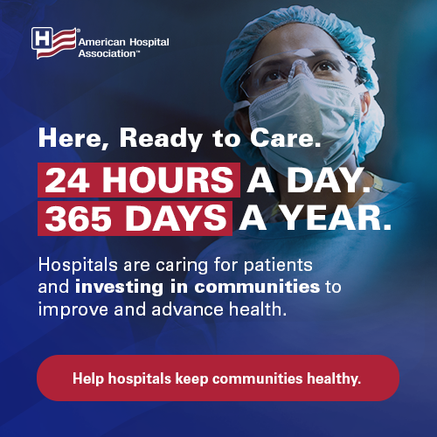

Post 2

America’s hospitals serve as anchors of care, safety, and innovation. 24 hours a day. 365 days a year—hospitals ensure access to quality care when it matters most.

In supporting hospitals, we not only care for patients, but also invest in the vitality and resilience of our communities.

Learn more:


