Honoring Better Health for Mothers and Babies
Summary: Each year, hospitals and health systems care for millions of mothers, deliver their babies, and comfort pediatric patients. In honor of September being NICU Awareness Month, and September 30 being NICU awareness day, the AHA would like to continue to recognize the incredible work that hospitals and healthcare professionals are providing to mothers and babies, within the NICU and beyond, each and every day. From Sept. 28-Oct. 2, the AHA will be honoring this important work by highlighting hospitals and providers, sharing heartwarming stories and distributing crucial resources on continuing to improve care for mothers and babies.
Whether they’re helping to improve maternal health outcomes or comforting new parents in the NICU, hospitals are there through it all.
We encourage you to tag us at @ahahospitals across social media, and share your own stories of maternal or child health and how hospitals have impacted that care. If you have any questions, please reach out to Hope Longe (hlonge@aha.org), AHA Sr. Social Media Specialist.
Link: https://www.aha.org/advocacy/maternal-and-child-health
Graphics:
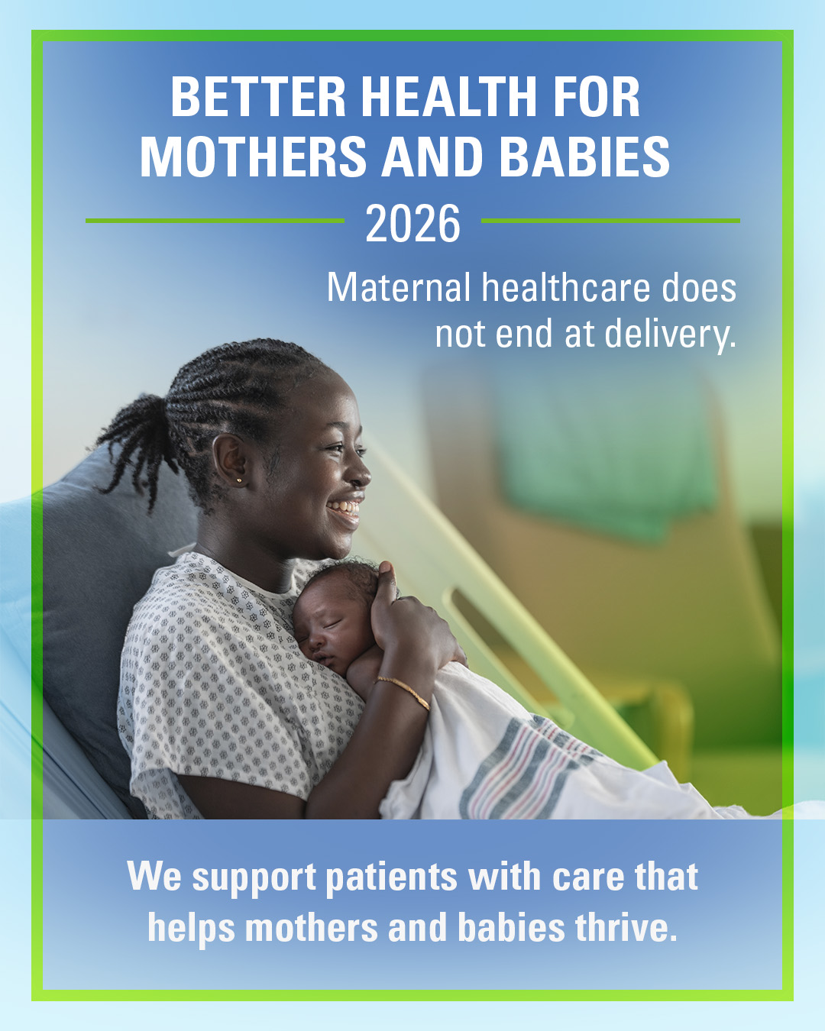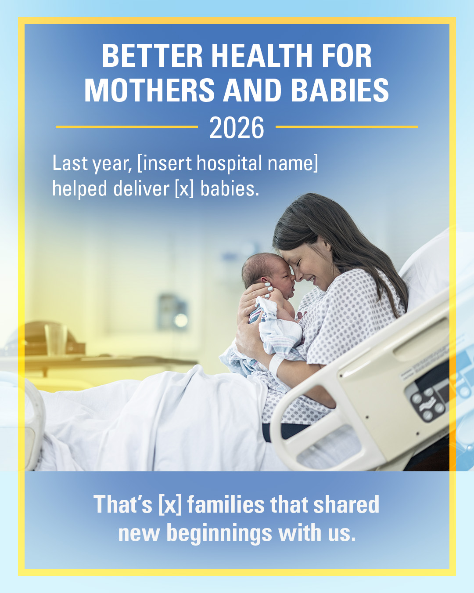
Sample Social Media:
At [insert hospital name] we are committed to providing high-quality care for mothers and their babies as they go from perinatal, to pregnancy, to postpartum. We’re always here for you, 24/7.

Last year, [insert hospital name] helped deliver [insert number] babies. That’s [insert number] of families that shared new beginnings with us.

Each year, our hospital will [insert anecdote about an initiative supporting maternal health]. That is just one example of the amazing work our teams are doing to care for maternal health patients.

Life’s new beginnings happen here at [insert hospital name]. From a newborn first cries, to the start of a new journey as parents.

When children need care, our pediatric teams at [insert hospital name] are here with compassion, skill and support for the whole family. From routine visits to complex care, we help kids get back to being kids.

In our NICU, every tiny milestone matters. At [insert hospital name], our neonatal care team supports premature and critically ill newborns and their families with advanced care, comfort and hope.

Our PICU team is ready when children need the highest level of care. At [insert hospital name], pediatric specialists, nurses and care teams work around the clock to treat serious illness and injury while supporting families every step of the way.

Maternal healthcare does not end at delivery. At [insert hospital name], we support patients before, during and after pregnancy with care that helps mothers and babies thrive.

Behind every safe delivery, NICU milestone, PICU recovery and pediatric visit is a dedicated care team. This week, we are proud to recognize the physicians, nurses and staff who care for mothers, babies and children every day.

Every patient journey is unique. At [insert hospital name], we are honored to be part of stories like [insert patient story], where compassionate care helped a mother, baby or child reach a meaningful milestone.

After spending [insert number] days in our NICU, [insert baby’s first name or “one newborn patient”] went home with their family. Moments like these remind us why every tiny milestone is worth celebrating.

When [insert child’s first name or “one young patient”] needed specialized pediatric care, our team worked together to support their recovery and help them return to the activities they love.

For [insert patient’s first name or “one new parent”], pregnancy and delivery brought unexpected challenges. With coordinated care from our maternal health team, they were able to safely welcome their baby and begin the next chapter of their family’s story.

Success can look like a first breath, a first feeding, a first step after surgery or a first ride home from the hospital. At [insert hospital name], we celebrate the patients and families who inspire our work every day.

